Coming out
Coming out is an extremely personal experience, there is no set way of doing it. Even if you plan it, it likely won’t go how you expect it, either! I remember spending weeks researching templates and writing a letter I would give to my mum. Before I had even finished it, I came out to my mum on the sofa because it popped up in a spontaneous conversation. It was extremely awkward, but I’m so glad I did it.
However, I know I’m fortunate to have a loving and accepting family. It’s important that you are coming out because you want to and you feel safe doing so. For those of you who are not yet out to certain people/anyone, remember that it's completely up to you whether you do come out and who to. It's okay not to come out at all or for it to be situationally dependent.
Your health and safety are more important. Not everyone can come out for various reasons. At times, it is very easy to forget how far the UK has come regarding LGBT+ equality, but around the world, and with certain intersections of people's identities, it's not always such a straightforward decision. It is a privilege to be out, and not always an option.
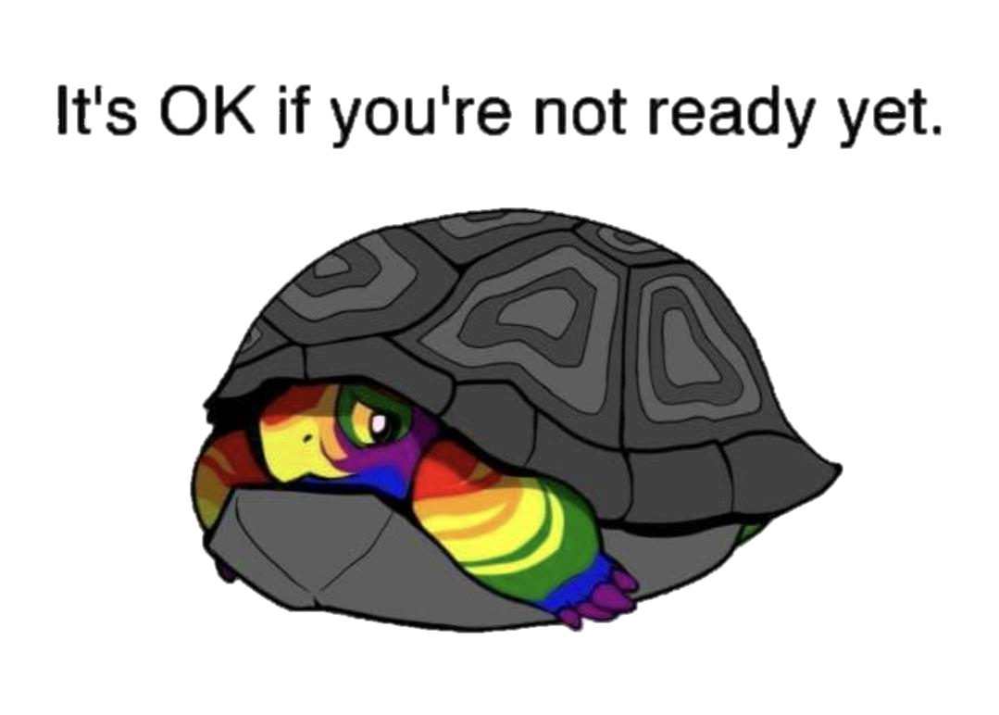

Here I’ve written some information that I hope will make things go as smoothly as possible if you make the decision to be out and authentically you.
Ways/tips on how to come out:

Writing
If you are a planner like me and feel you can express yourself better with the written word than you can in conversation, or the person you want to come out to lives far away, writing a letter might be a great way of doing this.
This can be done in various formats. If you want or feel the need to, you could write a long letter about when and how you first realised you were LGBT+, what your identity means and how nothing has changed. That you understand it might take them a while to understand, but you hope they will still love you.
If you don’t want to cover every inch of your story or it doesn’t feel appropriate, you could opt for a card or postcard and make a subtle but clear mention about being LGBT+. For example, when I came out as trans to my grandmother, I signed my letters with my name when she could still write letters to me. A clear message that my name had changed. Others have opted for sending postcards where they mention their partners or even attach pictures of them together, maybe at a Pride event.

Remote
If you are unable or are too anxious about the idea of doing it in person, you could opt for a videocall, phone call or even a text. The benefits of this are that you can still have a relatively personal touch (either through speaking or being able to see each other’s faces), but it’s also safe. If something goes wrong or the person starts being hateful, you are distanced away and not in immediate danger. Should you want to, you can also have notes by you that are out of sight. This will depend on your relationship with the person and how you want to go about it, but again you could either go through a full explanation of your journey and identity or introduce them to a new partner.

Social Media
We are now in an age where we have the wonders of technology. If a sit-down conversation with your 50+ sized family seems unrealistic, you could opt for either messaging individually/in a group chat or posting on your social media pages. Maybe it’s a long post or simply a picture from your first Pride with #QueerJoy #ComingOut

In-person
Probably the most traditional method, but one tried and tested option is doing it in person. Yes, that’s right, the awkward let’s-just-get-it-over-with conversation. Whether it’s your best mate, parent or even your teacher, there are still many ways to make it you. The first person I came out to saw me pace back and forth through our college common room a ridiculous number of times before they caught me and asked me what was happening. I blurted out that I’m gay. Not exactly how I planned, but just saying the words and having someone to listen and hug me felt like the world was being lifted off my shoulders. But you don’t have to blurt it in front of your college or an awkward sofa convo (unless you want to). You could ask your friend for coffee, a film hangout, or walk by the river. Or if you’re feeling brave, walk in holding hands with your partner or ask if they’ll go to Pride with you.
Tips on coming out:
Start gradually – you could start by telling a therapist so your information stays private and you have an unbiased soundboard who can help you work up to coming out to others.
Do it your way – just because your friend came out through a Facebook post and is loud and proud at Pride doesn’t mean you have to. Do it how you want to! You could even throw a coming out party – it doesn’t need to be done formally.
Every relationship is different – coming out is not a one-off experience. In fact, you’ll likely be coming out to different people for most of your life because the assumption is that being straight is the default. Okay, it won’t quite feel like the first time (and most people around you will eventually probably roll their eyes and correct people’s assumptions), but the point is that you don’t come out to just one person. It gets easier and more natural, but how you come out will likely depend on who you’re coming out to. It’s unlikely you’ll come out in the same way to your friends and your grandparents.
Do it because you want to – you have your whole life to go through your journey and truly discover who you are, so come out because you want to, not because other people expect you to. If you’re not ready, that’s okay!
If you need it, ask for help – if you’re unsure how someone will react or if how or when you’re coming out is a good idea, do a trial test! Do a practice run with your best friend and get their thoughts. If you know it will go badly no matter what, call in reinforcement buffers. Maybe if you’re coming out to your right-wing extended family, have your siblings and immediate family in the room so things don’t get too out of hand.
Test the waters – if you’re unsure where the person stands regarding LGBT+ views, you could test the water before coming out to get an idea if it’s safe. For example, maybe there’s a new LGBT+ character or show – “Heartstopper is on Netflix, what do you think of it?”. Perhaps a celebrity has recently come out – “Did you see that the Stranger Things actor Noah Schnapp recently came out as gay?”, or if the person you’re considering coming out to isn’t hot on pop culture, you could mention something that’s come up in the news and see how they react.
Make it clear how ‘out’ you want to be – the phrase outed means when someone tells someone else your LGBT+ identity without your permission. Sometimes this is done maliciously, but a lot of the time, it is done accidentally. So, make sure when you come out, you are clear about who can or doesn’t yet know (and if you want to keep it that way). This helps to prevent any awkward moments and embarrassing situations!
Things to consider before coming out.
It is your right to come out to anyone you want to, but there might be some things you want to consider before coming out to them. The biggest worry most LGBT+ people have before coming out to someone is rejection and our safety. So make sure you consider these things and what you can do to make it easier on yourself.
Here are 6 key questions to reflect on:
- Do you depend on this person for anything? E.g. housing, food, education, or finances.
- Are you part of a community that has not been very accepting of LGBT+ people?
- If you come out, could there be any repercussions? For instance, being cut off from certain family members, facing homophobia or being disallowed from certain events.
- Think about how your world could change: How might the people you tell react? Will they spread the word to someone you’d prefer didn’t know?
- When do you want to tell people? For instance, immediately or potentially wait until you have finished school, moved away for uni or even started a new job.
- Do you have a Plan B in place? – have a backup for what to do if they don’t accept you.

Questions you might get asked
An important consideration when coming out is being aware that communication is not a one-way street. They will likely have comments or questions to ask you after you’ve said your piece. Some will be more respectful than others, so be prepared!
For example, you might be asked:
- Are you sure this is not just a phase?
- How long/when did you first know?
- Why have you decided to tell me now?
- Maybe you just haven’t met the right man/woman yet?
- Who else knows? I think it’s best that you don’t tell [family member]
- What does [your identity] mean?
- So who’s the man/woman in the relationship?
- Does that mean you won’t have kids or get married?
- Are you wanting to have the surgery? I think you should wait until you’re older.
- How do you have sex?

What to do if it goes wrong
Things, unfortunately, don’t always go smoothly. I’m really sorry if you’ve come here because someone hasn’t accepted you. Know that it is nothing to do with you, that it is entirely their loss, and that you will always be welcome here.
The most important thing is that you are being/feeling authentically you and that you are safe.
- Consider your safety: are you or could you be in any immediate danger?
- If anyone you come out to reacts negatively, try and find a safe way to remove yourself from the situation. If their response involved verbal or physical abuse, you may want to report this to the police. See Reporting a Hate Crime for more information.
- Think about having an emergency contact – if anything goes wrong when you come out, this is the person (with their agreement) that you can call.
- Consider your accommodation – do you have your own place, or could you potentially be at risk of eviction? If things go badly, ensure you have somewhere you can stay for at least the night. See Homelessness and Risk of Estrangement for more information.
- Think about your education – is this paid or secured by the person you’re coming out to? Talk with your academic institution about any bursaries or support they offer for those who are at risk of estrangement.
- Give it time – it might simply be the initial shock of you coming out if it was unexpected for them. Perhaps once you have given time for the dust to settle, you can approach the conversation again later. For instance, it might be due to your parents worrying about the discrimination you will now be subjected to because it’s new for them. Or it might not. In which case, give yourself time to process these feelings.
- Get support – you don’t need to do this alone. Talk with a friend, family member or see the Further Resources for professional contacts, including helplines and organisations.
You likely will have a lot of thoughts and feelings to work through as you get to a point where you are thinking about coming out. You don’t need to do it alone.

